Chapter 1

INTRODUCTION TO SYSTEM

INTRODUCTION TO SYSTEM:-

The aim of Saraswati spices website is to be gives information about product, rate and quantity .Our natural organic range spices, spices mixes and aromatic herbs are just a perfect for regular home cooking a professional cooks. Our spices are Freshness and goodness.

Black peeper, turmeric,chilli,clove,cardomon, and so many spices we have it.Thissystem easy to handle by owner ,also registration can e maintained by the system.Feedback is also maintained by this system.This information is available by owner of the system.

ADVANTAGES OF SYSTEM:-

1. It required less time.
2. Increase the sales.
3. Resourceful in marketing and advertising.
4. Searching of data can be easy.
5. Reach out to more clients.
6. The products are handicapted to ensure the highest quality.

LIMITATIONS OF SYSTEM:-

* At a time only one user use can this system.
* In this system online payment cannot provide.
* The manual system is difficult to handle.
* In the existing system, it is very difficult to keep track several of document and record.
* Data security is not maintained due to open location document and file is not safe.There is a risk of unauthorized access.

EXISTING SYSTEM:-

In the existing system details are maintained manually due to this the data received is time consuming due to human calculation error occurs even when the data is maintained on spread sheets inconsistency occurs as an order might be missed .

CHAPTER 2

ORAGANIZATION OF PROFILE

CHAPTER 2

ORGANISATION

PROFILE

(A)ORAGANIZATION OF PROFILE:-

Saraswati spices private limited is a non-government company.It is located at islampur, tal-Walwa, Dist-Sangali.This business is started on 30thOct 1998 by Mahesh Chandrakant phulit. Saraswati enterprises have 4 employees across all of its locations.

Saraswati spices private limited is majorly in business services business from last 14 years and currently.

(B) ORAGANIZATION CHART:-

Owner

Employee

ABO

Customer

CHAPTER 3

INTRODUCTION TO HTML

INTRODUCTION TO HTML:-

HTML stands for hyper text markup language .hyper textmarkup language is an ordinary text that has extra features such as formatting multiplication link to other document. Markup is the process of taking ordinary text and adding extra symbols to that text such as editor reading symbol is type of markup. Each of the symbol used for markup in html is command that brewers how to display the text.

A web browsers is a program that automatically interprets that HTML and format web document according to that.

FEATURES OF HTML:-

HTML is the most common used language to write web page. It has a recently gained popular due to its feature such as:-

1. It is the language which can be easily understood and can be modified.

2. Effective presentations can be made with the HTML with the help of its all formatting tags.

3. It provides the more flexible way to design web pages along with the text.

4. Links can also be added to the web pages .it helps the readers to browse the information of their interest.

5. You can display HTML documents on any platform such as Macintosh, Windows and Linux etc.

6. Graphics, videos and sounds can also be added to the web pages which given an extra attractive look to your web pages.

ADVANTAGES OF HTML:-

1. It is easy to understand as compare to other programming language.

2. For creating HTML document newly only text create there is no requirement of special software.

3. If something is not working then finding of error is easy in HTML.

4. HTML document can create an only hardware platform using text editor.

5. You can work indepentally without depending other programms.

6. It is a best method for desgning web page.

7. You we have much better concept of structure of your page and understanding of its .

CHAPTER 4

SYSTEM ANALYSIS

AND DESIGN

1. FEASIBILITY STUDY

The feasibility study is useful to evaluate the cost and benefits of the system. The feasibility study tries to anticipate future scenario of softer development.

There are three measure aspects as:

1. Technical feasibility study.
2. Operational feasibility study.
3. Economical feasibility study.

* Preliminary investigation:-

To design the system or to solve any problem related to the system we must study the system deeply. to get deeper knowledge about system examine the existing system many times ,ask questions to different people, note down the important points ,study different papers, register to system etc.

* Interviews:-

Interview technique is used to collect the information from individual or group of people. The interview must be planned must be planned we must choose place and time according to Interviewer.

Interviewcan be clear doubts. This method helps to find out misunderstanding areas; expectations etc .it is time consuming method.

* On site observations:-

By interviewing people ,I get the information about system which helps me to understand the system , I have studied different manuals , different reports , different reports etc. and get more knowledge about the existing system.

* Questionnaire:-

By questing to different people we get answers for queries in our mind .the success of collecting date through a questionnaire helps to design system. The open response questionnaire are used to learn about the opinion, feeling and general experience about the whole process. questionnaires are give what are most important needs for agent that a new system should satisfy.

2.FEASIBILITY STUDY

The feasibility study is useful to evaluate the cost and benefits of the system . the feasibility study tries to anticipate future scenario of softer

development

There are three measure aspects as:

1.Technical feasibility study.

2.Operational feasibility study.

3.Economical feasibility study.

* Technical feasibility study:

Technical feasibility study is always focuses on existing hardware and software. This also includes the need for more hardware and software and possibility of installing such a facility.

* Operational feasibility study :

The operational feasibility study is related to want exactly operations are performed .it consider the acceptability of the system . it checks whether system is used if it is develop and able to handle the system .

* Economical feasibility study :

The economical feasibility considers the cost or benefits or proposed system . the benefits to over waiting coat, development cost, investment cost, salaries and main

System data flow chart:-

LOGIN

WEBSITE FOR SARASWATI SPICES

Chili

Cinnamon

Clove

Cardamom

Turmeric

Saffron

HOME

FEEDBACK

CONTACT US

ABOUT US

PRODUCT

CHAPTER 5

IMPLEMENTATION

SYSTEM REQURIMENT

Hardware Requriment:-

* Monitor
* Laptop
* Keyboard
* Mouse
* Printer

Software Requriment:-

* Notepad
* Microsoft office
* Chrom
* Antivirus software

Uses languages:-

* HTML
* CSS
* Java script

USER MANUAL

When we run the project the main page open .In this page we can see the option -Home, Product’s, About us, Contact us, feedback.

* Home:-

Home page display introduction of system.

* Product’s:-

In this web page display the list of products

List of products:

1.Turmeric

2.Chilli

3.Clove

4.Cardamom

5.Black peeper

6.Cinnamon

7.Cumin

* About us:-

About us page display the speciality of the system.

* Contact us:-

Contact page display the details of the system.

* Feedback:

Feedback page is help of user and they can give their information and write the comments and suggestions.

CHAPTER 6

SOURCE CODING

HOME

<html>

<head>

<style>

body{

width:100%;

background-image:url("12.jpg");

background-position:center;

background-size:cover;

height:100%;

}

.anaglyph{

letter-spacing:6px;

text-shadow:red 0 0, cyan 0 0;

transition: text-shadow;

}

.anaglyph:hover{

text-shadow:red -6px 0,cyan 6px 0;

}

nav{

background-color:;

display:grid;

place-items: left;

}

nav ul{

list-style-type:none;

}

nav ul a{

display: inline-block;

padding:10px;

text-decoration:none;

color:#000;

transition:0.2s ease-in;

font-size:15px;

}

nav ul a:hover{

background-color:ORANGE;

color:gold;

}

.search{

float: right;

margin-right:50px;

height: 35px;

}

.srch{

font-family: 'Times New Roman';

width: 200px;

height: 35px;

background: transparent;

border: 1px solid #ff7200;

margin-top:10px;

color:#fff;

border-right: none;

font-size: 16px;

float: left;

padding: 5px;

border-bottom-right-radius: 5px;

border-top-right-radius: 3px;

}

.btn{

width: 100px;

height:40px;

background:#ff7200;

border:2px solid #ff7200;

margin-top: 5px;

color:#fff;

font-size: 15px;

border-bottom-left-radius:5px;

border-bottom-left-radius:5px;

}

.btn:focus{

outline: none;

}

.search: focus{

outline: none;

}

.srch:focus{

outline:none;

}

b{

text-align:center;

color:red;

font-style:arial;

}

</style>

</head>

<div class="search">

<input class="srch" type="search" name="" placeholder="type to text">

<a href ="#"><button class="btn">search</button></a>

</div>

<body>

<nav>

<ul>

<a href="1page.html"><li>HOME</li></a>

<a href="new.html"><li>PRODUCT'S</li></a>

<a href="about us.html"><li>ABOUT US</li></a>

<a href="contact us.html"><li>CONTACT US</li></a>

<a href="feedback.html"><li>FEEDBACK</li></a>

</ul>

</nav>

<center>

<div class="anaglyph">

<h1>Saraswati Spices</h1>

</div></center>

</body>

</html>

PRODUCT’S

<!DOCTYPE html>

<html>

<head>

<title></TITLE>

<style>

h1{

text-align:center;

color:red;

}

*{

margine:0;

padding:0;

font-family:sans-serif;

box -sizing:border-box;

}

nav{

background-color:white;

display:grid;

place-items: left;

}

nav ul{

list-style-type:none;

}

nav ul a{

display: inline-block;

padding:10px;

text-decoration:none;

color:#000;

transition:0.2s ease-in;

font-size:15px;

}

nav ul a:hover{

background-color:ORANGE;

color:gold;

}

.items{

display:grid;

grid-template-columns: repeat(3, 1fr);

padding: 30px 20px;

grid-row-gap:30px;

}

.item img{

float:center;

width:350px;

height:400px;

object-fit:cover;

cursor:pointer;

transition:0.2s ease;

}

.item img:hover{

transform:scale(1.04);

}

.item h2{

padding :5px;

text-align:center;

}

.item button{

padding:5px; 30px;

border:none;

outline:none;

background-color:GREEN;

color:white;

cursor:pointer;

border-radius:4px;

font-size:20px;

display:block;

margin:0 auto;

transition: 0.2s all;

color:white;

}

.item button:hover{

transform:scale(1.08);

}

@media screen and(max-widh:768px){

.items{

grid-template-columns:repeat(1, 1fr);

}

@media screen and(max-widh:768px){

.items{

grid-template-columns:repeat(1, 1fr);

}

a{

color:darkwhite;

}

</head>

</style>

<body>

<h1>Saraswati Spices</H1>

<nav>

<ul>

<a href="1page.html"><li>HOME</li></a>

<a href="new.html"><li>PRODUCT'S</li></a>

<a href="about us.html"><li>ABOUT US</li></a>

<a href="contact us.html"><li>CONTACT US</li></a>

<a href="feedback.html"><li>FEEDBACK</li></a>

</ul>

</nav>

<section class="items">

<div class="item">

<a href="login.html"><img src="chili4.jpg"></a>

<h2>Chilli</h2>

<center><h3>120rs</h3>

<button>BUY NOW</button>

</div>

<div class="item">

<a href="login.html"><img src="cinnamon4.jpg"></a>

<h2>Cinnamon</h2>

<center><h3>120rs</h3>

<button>BUY NOW</button>

</div>

<div class="item">

<a href="login.html"><img src="clove.png"></a>

<h2>Clove</h2>

<center><h3>120rs</h3>

<button>BUY NOW</a></button>

</div>

<div class="item">

<a href="login.html"><img src="cardamam8mm-370x370.jpg"></a>

<h2>Cardamaom</h2>

<center><h3>120rs</h3>

<button>BUY NOW</button>

</div>

<div class="item">

<a href="login.html"><img src="turmeric2.jpg"></a>

<h2>Turmeric</h2>

<center><h3>120rs</h3>

<button>BUY NOW</button>

</div>

<div class="item">

<a href="login.html"><img src="prod-1.jpg"></a>

<h2>Chilli</h2>

<center><h3>120rs</h3>

<button>BUY NOW</button>

</div>

</section>

</body>

</html>

LOGIN PAGE

<html>

<head>

<style>

nav{

background-color:;

display:grid;

place-items: left;

}

nav ul{

list-style-type:none;

}

nav ul a{

display: inline-block;

padding:10px;

text-decoration:none;

color:white;

transition:0.2s ease-in;

font-size:15px;

}

nav ul a:hover{

background-color:ORANGE;

color:gold;

}

.search{

float: right;

margin-right:50px;

height: 35px;

}

.srch{

font-family: 'Times New Roman';

width: 200px;

height: 35px;

background: transparent;

border: 1px solid #ff7200;

margin-top:10px;

color:#fff;

border-right: none;

font-size: 16px;

float: left;

padding: 5px;

border-bottom-right-radius: 5px;

border-top-right-radius: 3px;

}

*{

margine: 0 ;

padding: 0;

font-family:sans-serif;

}

body{

height:100%;

width:100%;

background-image:url("img100.jpg");

background-position:center;

background-size:cover;

position:absolute;

}

.form-box{

width:500px;

height:500px;

position:relative;

margin:6% auto;

background: #fff ;

padding:5px;

background-color:lightgray;

overflow: hidden;

}

.button-box{

width:220px;

margin:35px auto;

position:relative;

box-shadow:0 0 20px 9px #ff61241f;

border-radius:30px;

}

.toggle-btn{

padding: 10px 30px;

cursor:pointer;

background: transparent;

border:0;

outline:none;

position:relative;

}

#btn{

top: 0;

left: 0;

position:absolute;

width:110px;

height:100%;

background-color:;

background-color:;

border-radius: 30px;

transition: .5s;

}

social-icons{

margin:30px auto;

text-align:center;

}

.social-icons img{

width:40px;

margin:0 12px;

box-shadow:0 0 20px 0 #7f7f7f3d;

cursor:pointer;

border-radius:50%;

}

.input-group{

top: 180px;

position:absolute;

width:280px;

transition: .5s;

}

.input-field{

width: 100%;

padding: 10px 0;

margin: 5px 0;

border-left: 0;

border-top: 0;

border-right: 0;

border-bottom: 0;

border-bottom:1px solid #999;

outline: none;

background: transparent;

}

.submit-btn{

width:85%;

padding:10px 30px;

cursor: pointer;

background: inear-gardient(to all, #ff105f, #ffad06);

display: block;

margine: auto;

border:0;

outline:none;

border-radius:30px;

}

.checkbox{

margin: 30px 10px 30px 0;

}

.span{

color: #777;

font-size: 12px;

bottom: 68px;

position: absolute;

}

login{

position: absolute;

background-color:orange;

background: transparent;

}

h1{

color:white;

font-size: 48px;

</style>

</head>

<nav>

<ul>

<a href="1page.html"><li>HOME</li></a>

<a href="new.html"><li>PRODUCT'S</li></a>

<a href="about us.html"><li>ABOUT US</li></a>

<a href="contact us.html"><li>CONTACT US</li></a>

<a href="feedback.html"><li>FEEDBACK</li></a>

</ul>

</nav>

<div>

<body>

<div class="hero">

<div class="form-box">

<div class="button-box">

<div id="btn"></div>

<button type="button" class="toggle-btn">Log In</button>

</div>

<center>

<div class="social-icons">

<img src="fb.png">

<img src="th (3).jpg">

<img src="th (4).jpg">

</div>

<form id="login" class="input-group">

<input type="text" class="input-field" placeholder="user Id" required>

<input type="text" class="input-field" placeholder="Enter Password" required>

<p>

<br>

<input type="checkbox" class=check-box"><span>Remember Password</span>

<p>

<br>

class="submit-btn">Log in</button>

</div>

</center>

</body>

</html>

ABOUT US

<html>

<head>

<style>

*{

margine:0;

padding:0;

font-family:sans-serif;

box -sizing:border-box;

}

nav{

background-color:white;

display:grid;

place-items: left;

WIDTH:100%;

}

nav ul{

list-style-type:none;

}

nav ul a{

display: inline-block;

padding:10px;

text-decoration:none;

color:#000;

transition:0.2s ease-in;

font-size:16px;

}

nav ul a:hover{

background-color:ORANGE;

color:gold;

}

.floating-box{

background-color: lightblue;

float:left;

width:380;

height:350;

margin:10px;

border:3px solid black;

color:white;

}

.floating-box1{

background-color:orange;

float:left;

width:380;

height:350;

margin:10px;

border:3px solid black;

color:white;

}

.floating-box2{

background-color:lightpink;

float:left;

width:380;

height:350;

margin:10px;

border:3px solid black;

color:white;

}

.floating-box3{

Background-color:lightgreen;

Float:left;

width:380;

height:350;

margin:10px;

border:3px solid black;

color:white;

}

.floating-box4{

background-color:;

height:50%;

width:100%;

scroll-snap-type: x mandatory y mandatory;

;

scroll-snap-align: start;

}

.container{

scroll-snap-type: x mandatory;

}

.child{

scroll-snap-align: start;

}

body{

font-style: sans-serif;

}

.items{

display:flex;

overflow-x:auto;

}

.items::webkit-scrollbar{

display:none;

}

.items.item{

width:50%;

height:50%;

background:#ddd;

margin:10px;

}

b{

color:red;

}

</style>

</head>

<body>

<center>

<b><h1>Saraswati Spices</h1></b>

</center>

<nav>

<ul>

<a href="1page.html"><li>HOME</li></a>

<a href="new.html"><li>PRODUCT'S</li></a>

<a href="about us.html"><li>ABOUT US</li></a>

<a href="contact us.html"><li>CONTACT US</li></a>

<a href="feedback.html"><li>FEEDBACK</li></a>

</ul>

</nav>

<center>

<img src="11.png" height="45%" width="40%" border="2px solid black">

<img src="spicess.png" height="45%" width="40%" border="2px solid black">

<center><h1>why buy from us?</h1></center>

<div="floating box">

<div class="floating-box"><h1>1.<br>Carefully picked</h1><h2>"Saraswati Spices" carefully picked directly from the farmers to ensure high quality</div>

<div class="floating-box1"><h1>2.<br>Freshly processed<h2> Spices are processed scientifically so that are aroma and flavors are preserved.</div>

<div class="floating-box2"><h1>3.<br>Securely packed <h2>We ensure that the packages are securely sealed so that the products wii reach you without any hamper.</div>

<div class="floating-box3"><h1>4.<br>Fast diliver <h2>Product are reaching you as fast as possible.</div>

</center>

<div class="floating-box4">

</div>

<div class="items">

<div class="item">

<img src="th (9).jpg" height="450px" width="500px">

</div>

<div class=item"">

<img src="turmic.3.jpg" height="450px" width="500px">

</div>

<div class="item">

<img src="cinnamon4.jpg" height="450px" width="500px">

</div>

<div class="item">

<img src="cardamaom.jpg" height="450px" width="500px">

</div>

<div class="item">

<img src="prod-1.jpg" height="450px" width="500px">

</div>

<brss>

<div class="item">

<img src="clove.png" height="450px" width="500px">

</div>

CONTACT US

<html>

<head>

<style>

h1{

color:red;

text-align:center;

}

nav{

background-color:white;

display:grid;

place-items: left;

}

nav ul{

list-style-type:none;

}

nav ul a{

display: inline-block;

padding:10px;

text-decoration:none;

color:#000;

transition:0.2s ease-in;

font-size:15px;

}

nav ul a:hover{

background-color:ORANGE;

color:gold;

}

.floating-box{

background-color:lightgray;

float:left;

width:350;

height:150;

margin:10px;

border:1px solid gray;

color:lightblack;

}

.floating-box1{

background-color:lightgray;

float:left;

width:350;

height:150;

margin:10px;

border:1px solid gray;

color:lightblack;

}

.floating-box2{

background-color:lightgray;

float:left;

width:350;

height:150;

margin:10px;

border:1px solid gray;

color:black;

}

.floating-box3{

background-color:lightgray;

float:left;

width:350;

height:150;

margin:10px;

border:1px solid gray;

color:black;

}

img{

float:left;

height:60%;

}

</style>

</head>

<body>

<h1>Saraswati Spices</h1>

<nav>

<ul>

<a href="1page.html"><li>HOME</li></a>

<a href="new.html"><li>PRODUCT'S</li></a>

<a href="about us.html"><li>ABOUT US</li></a>

<a href="contact us.html"><li>CONTACT US</li></a>

<a href="feedback.html"><li>FEEDBACK</li></a>

</ul>

</nav>

<center>

<img src="image1.jpg"height="50%" width="100%">

<div>

<div class="floating-box"> <h3>Address</h3><br> Near Gandhi chowk 3rd lane<br>Islampur</div>

<div class="floating-box1"><h3>phone no</h3> +91-8975332299<br>+91-7558587241</div>

<div class="floating-box2"><h3>E-mail</h3><br>Saraswati spices@gmail.com</div>

<div class="floating-box3"><h3>Customer care no</h3><br>+91-7856489067<br>+91-8890457689</div></center>

<p>

<img src="th (1).jpg" "height="30%" width="50%">

<img src="3.jpg" "height="100%" width="50%">

</body>

</html>

FEEDBACK FORM

<html>

<head>

<style>

body{

width:100%;

background-image:url("img100.jpg");

background-position:center;

background-size:cover;

height:100%;

}

nav{

background-color: ;

display:grid;

place-items:left;

}

nav ul{

list-style-type:none;

}

nav ul a{

display: inline-block;

padding:10px;

text-decoration:none;

color:white;

transition:0.2s ease-in;

font-size:15px;

}

nav ul a:hover{

background-color:oranges;

color:gold;

}

input[type=text],select {

width:500px;

padding:12px 30px;

margin:8px 0;

display:inline-block;

border:1px solid gray;

border-radius:4px;

box-sizing:border-box;

}

input[type=submit]{

float:center;

width:30%;

background-color:green;

color:white;

padding:14px 20px;

margin:1px 0;

border:none;

border-radius:4px;

cursor:pointer;

}

div {

width:50%;

height:600px;

left-margin:8px 8px;

left-padding:30%;

border-radius:5px;

background-color:#f2f2f2;

}

</style>

</body>

<nav>

<ul>

<a href="1page.html"><li>HOME</li></a>

<a href="new.html"><li>PRODUCT'S</li></a>

<a href="about us.html"><li>ABOUT US</li></a>

<a href="contact us.html"><li>CONTACT US</li></a>

<a href="feedback.html"><li>FEEDBACK</li></a>

</ul>

</nav>

<center>

<div>

<center>

<h1>Feedback Form</h3></center>

<center>

<form action="/action_page.php">

<h3><lable for="fname"><br>First Name</lable>

<input type="text" id=name name="firstname"

placeholder="Your name..">

<p>

<lable for="lname"><br>Last Name</lable>

<input type="text" id=name name="lastname"

placeholder="Your last name..">

<p>

<lable for="email"><br>E-mail Id</lable>

<input type="text" id=name name="email-id"

placeholder="Your E-mail id..">

<p>

<lable for="comment/suggestions"><br>Comment/Suggestions</lable>

<input type="text" id=name name="comment/suggestions"

placeholder="Comment/Suggestions..">

<p>

<input type="submit" value="submit">

</form>

</div>

</body>

</html>

CHAPTER 7

OUTPUT DESIGN

HOME

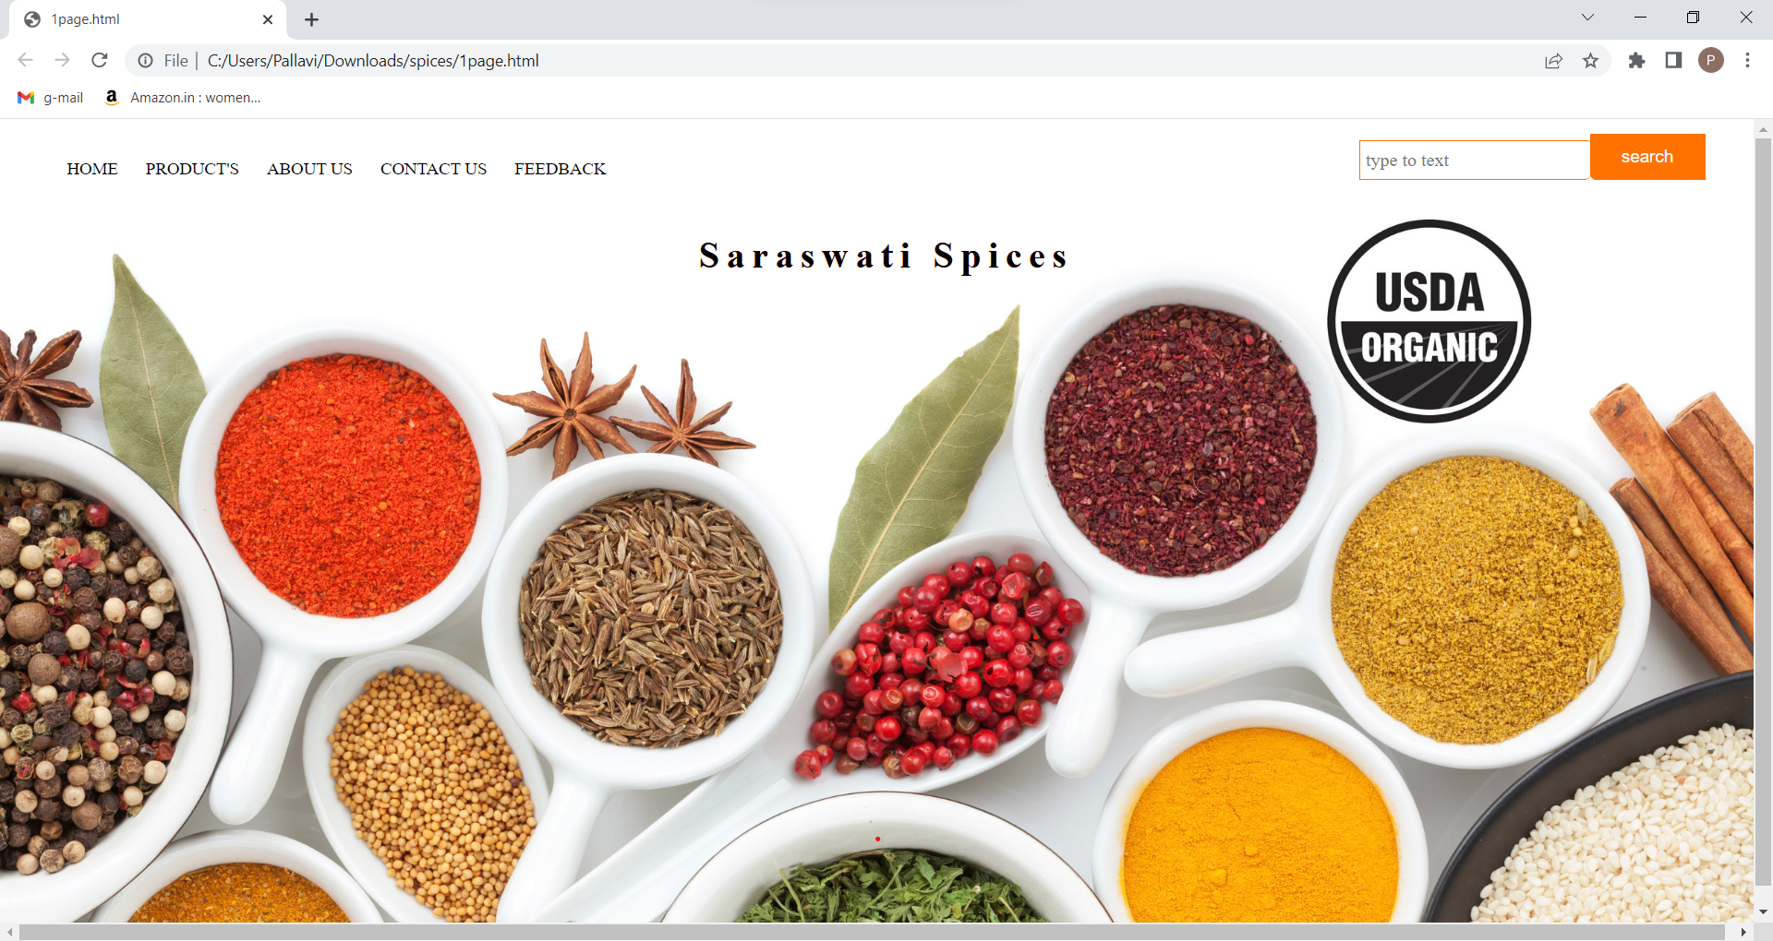

PRODUCT’S

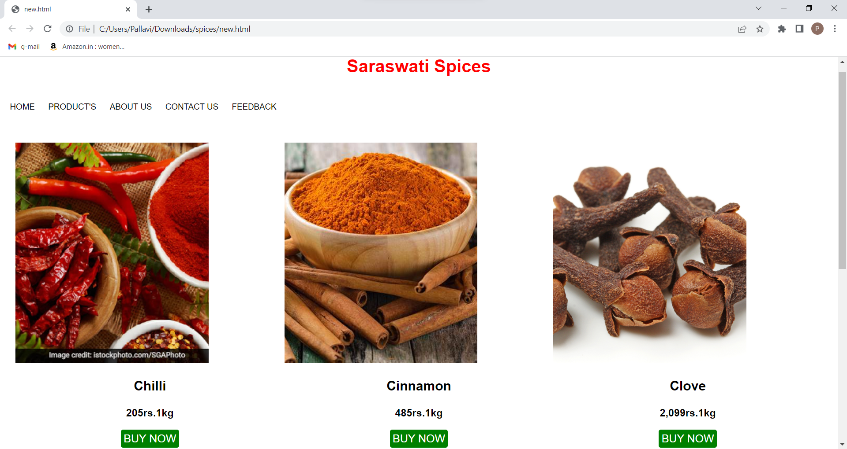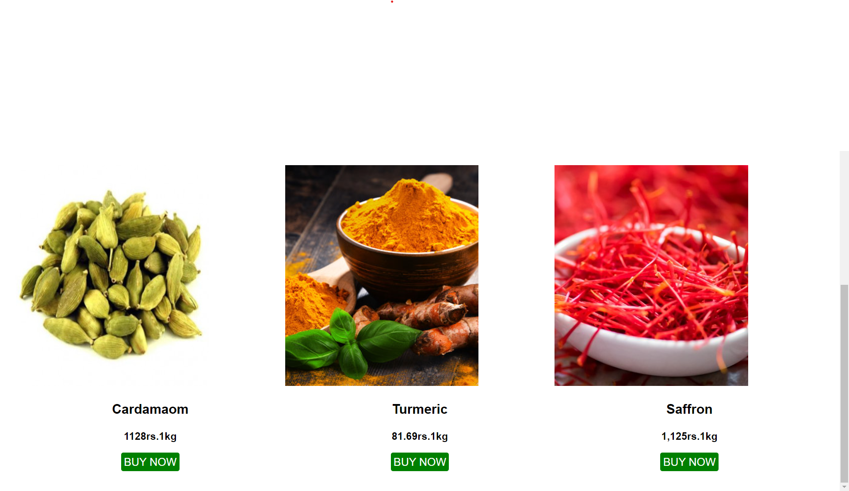

LOGIN PAGE

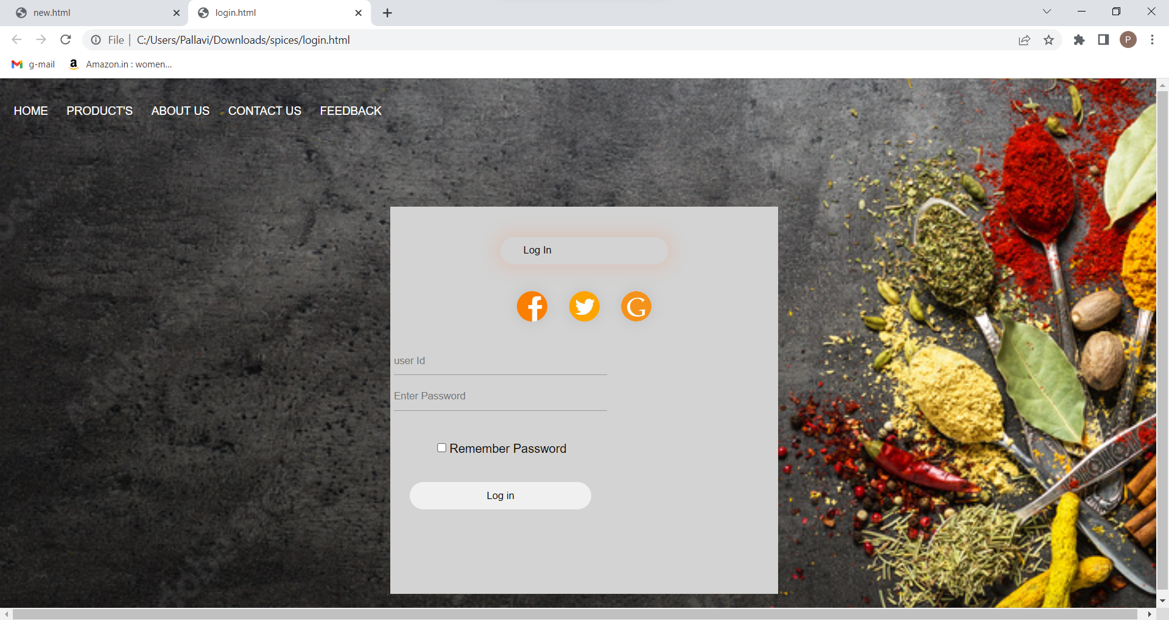

ABOUT US

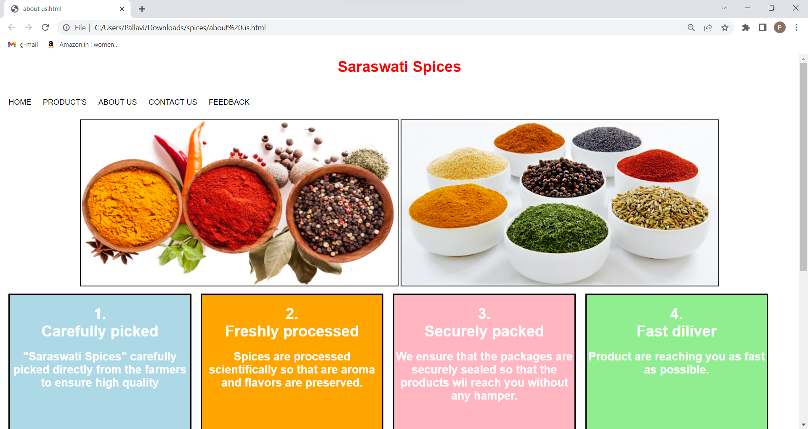

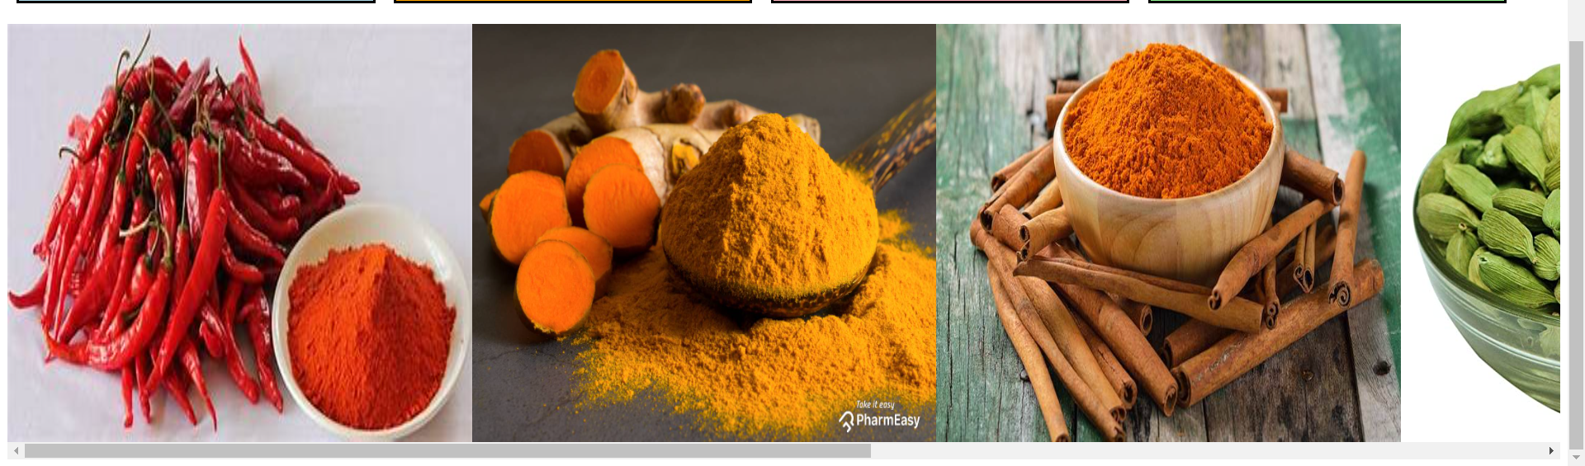

CONTACT US

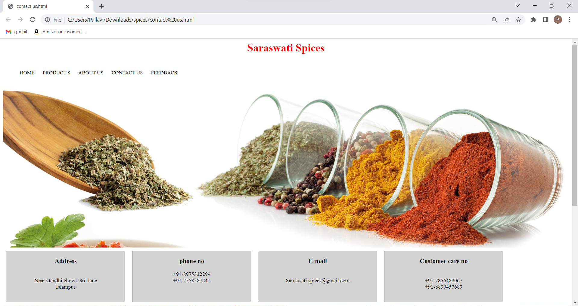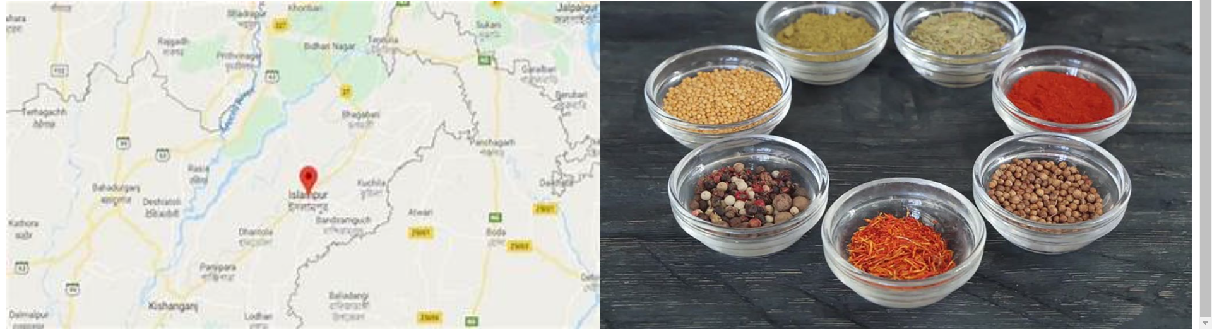

FEEDBACK FORM

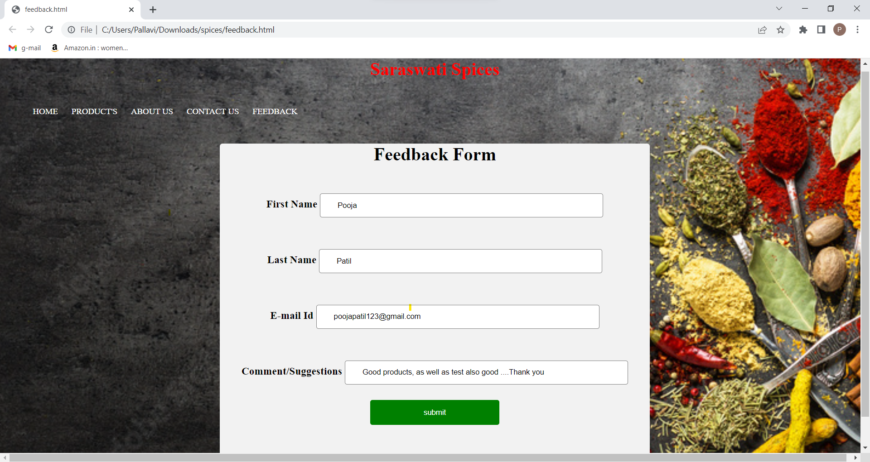

CHAPTER 8

CONCLUSION

CONCLUSION

This project developed, incorporated all the activities involved in the browsing center.

It provides all necessary information to the management as well as the customer with the use of this system; the user can simply sit in front of the system and monitor all the activities without any physical movement of the file. Management can service the customers request best in time.

The system provides quickly and valuable information. These modules have been integrated for effective use of the management for future forecasting and for the current need.

CHAPTER 9

BIBLIOGRAPHY

BIBLIOGRAPHY

* Reference websites
  + - [www.w3schools.com](http://www.w3schools.com)
    - Spicesbasket.in
* Reference Books

1.HTML:

- Yashwant Kanitakar.

2.Web Technology:

-Madhu Chauhan

- Kanika Bhalla.